1. Download VTube Studio (Free on Steam)

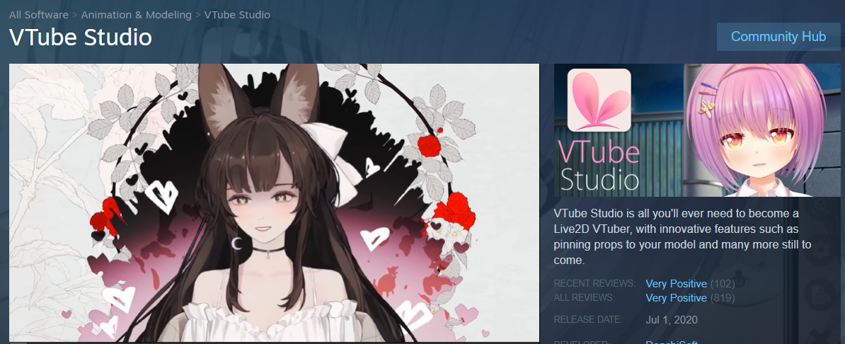

1. Open VTube Studio
2. On the side panel, click the settings button
   1. You may need to double click to bring up the side panel

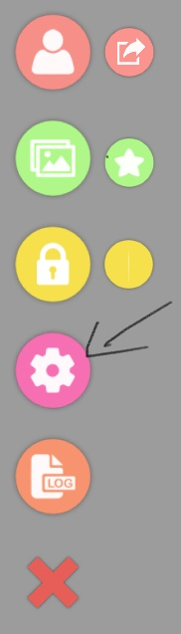

1. Go to the settings tab, and choose the “Open Data Folder” Button

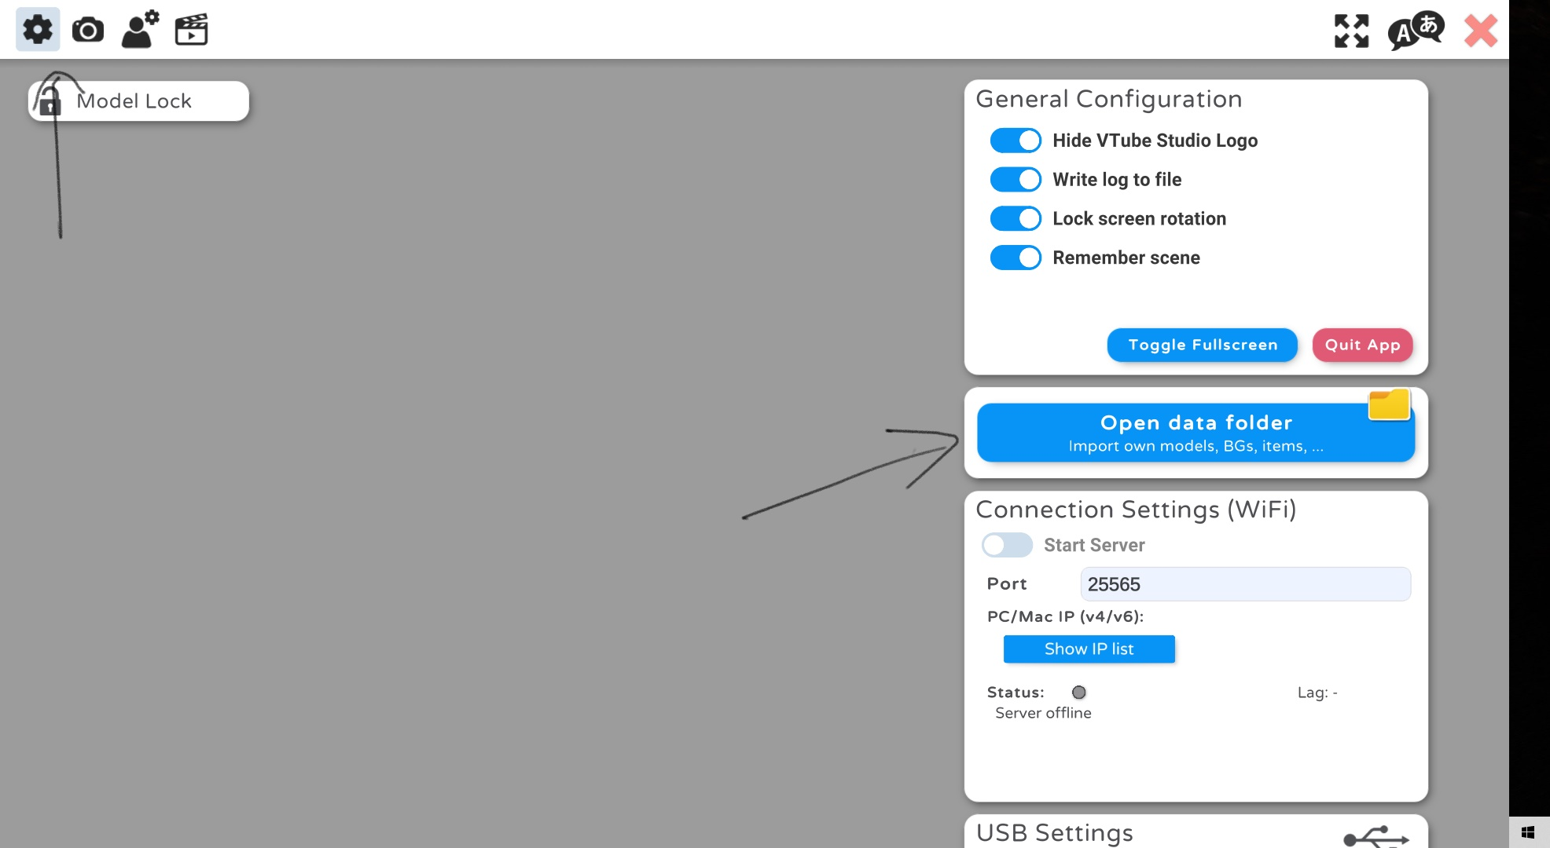

1. Place the unzipped Model folder in the “Live2DModels” directory

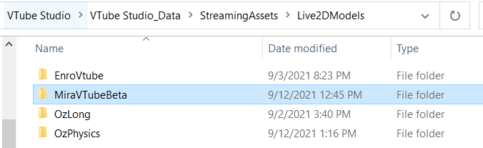

1. Restart VTube Studio
2. Open the side panel and select the models button
   1. Select Mira’s model and you’re ready to go!

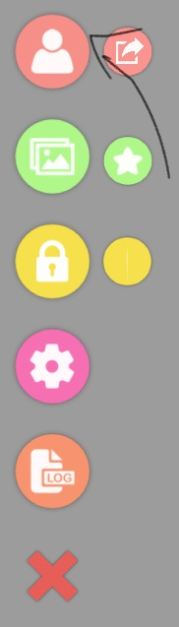

1. The model should already be set up with animations. Use the “1” key on you keyboard to toggle the tail eyes open. If this is not working, go to the animations tab and replicate the settings below. You can press the “rec” button to choose a different hotkey if you wish.

